This letter is to certify your in-kind, tax deductible contribution to Grace House Ministries of the items listed below. Establishing the dollar value of in-kind donations is the exclusive responsibility of the donor.

Date:

Items:

Description:

Grace House’s Federal Tax-ID number is 57-0903169. No goods or services were provided by the organization in exchange for this contribution.

Sincerely,

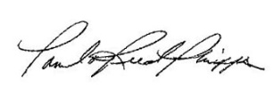

Pamela Reed Phipps
Executive Director

